**Practical 9: Introduction to collection framework**

Name: Sutariya Savankumar

Roll no: MA065

1. **Write Create an ArrayList and perform following operations for that:**
   1. **Add**
   2. **Update**
   3. **Delete**
   4. **Convert in to array**
   5. **Display using iterator()**

Code

import java.util.ArrayList;

import java.util.Iterator;

public class p1 {

    public static void main(String[] args) {

        // Create an ArrayList of strings

        ArrayList<String> fruits = new ArrayList<String>();

        // Add elements to the ArrayList

        fruits.add("apple");

        fruits.add("banana");

        fruits.add("orange");

        fruits.add("grape");

        // Print the ArrayList

        System.out.println("ArrayList: " + fruits);

        // Update an element in the ArrayList

        fruits.set(1, "kiwi");

        // Print the ArrayList after update

        System.out.println("ArrayList after update: " + fruits);

        // Delete an element from the ArrayList

        fruits.remove(2);

        // Print the ArrayList after delete

        System.out.println("ArrayList after delete: " + fruits);

        // Convert the ArrayList to an array

        String[] fruitsArray = fruits.toArray(new String[0]);

        // Print the array

        System.out.println("Array: ");

        for (String fruit : fruitsArray) {

            System.out.println(fruit);

        }

        // Display the ArrayList using iterator()

        System.out.println("ArrayList using iterator(): ");

        Iterator<String> iterator = fruits.iterator();

        while (iterator.hasNext()) {

            System.out.println(iterator.next());

        }

    }

}

Output

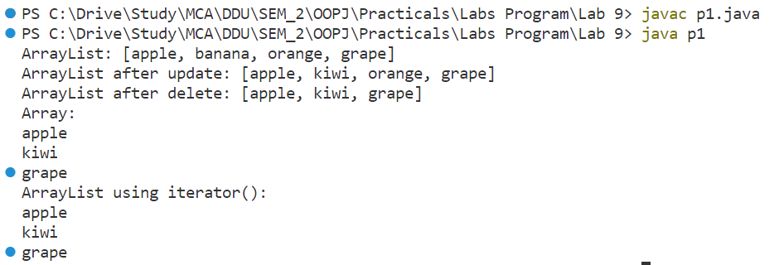

1. **Create a LinkedList and perform following operations for that:**
   1. **Insert at first**
   2. **Insert at last**
   3. **Delete from first**
   4. **Delete from last**
   5. **Update specific index node value**
   6. **Remove from specific index**
   7. **Display using iterator()**

Code

import java.util.LinkedList;

import java.util.ListIterator;

public class p2 {

    public static void main(String[] args) {

        // Create a new LinkedList

        LinkedList<String> linkedList = new LinkedList<String>();

        // Insert elements at the beginning of the LinkedList

        linkedList.addFirst("apple");

        linkedList.addFirst("banana");

        linkedList.addFirst("orange");

        System.out.println("LinkedList after adding elements at the beginning: " + linkedList);

        // Insert elements at the end of the LinkedList

        linkedList.addLast("pear");

        linkedList.addLast("grape");

        linkedList.addLast("pineapple");

        System.out.println("LinkedList after adding elements at the end: " + linkedList);

        // Delete the first element of the LinkedList

        linkedList.removeFirst();

        System.out.println("LinkedList after deleting the first element: " + linkedList);

        // Delete the last element of the LinkedList

        linkedList.removeLast();

        System.out.println("LinkedList after deleting the last element: " + linkedList);

        // Update the value of an element at a specific index

        linkedList.set(1, "cherry");

        System.out.println("LinkedList after updating the value of an element at index 1: " + linkedList);

        // Remove an element from a specific index

        linkedList.remove(2);

        System.out.println("LinkedList after removing an element from index 2: " + linkedList);

        // Display the LinkedList using an iterator

        ListIterator<String> iterator = linkedList.listIterator();

        System.out.print("LinkedList using iterator: ");

        while (iterator.hasNext()) {

            System.out.print(iterator.next() + " ");

        }

    }

}

Output

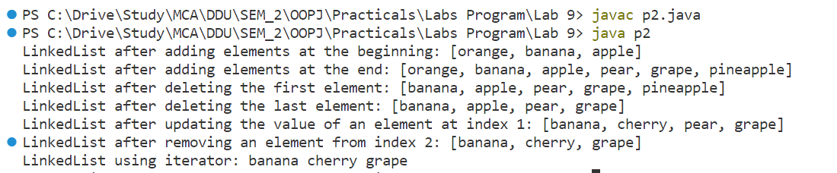

1. **Create a HashSet and perform following operations for that:**
   1. **Insert**
   2. **Update**
   3. **Delete**
   4. **Display using iterator()**

Code

import java.util.HashSet;

import java.util.Iterator;

public class p3 {

    public static void main(String[] args) {

        // Create a new HashSet

        HashSet<String> hashSet = new HashSet<String>();

        // Insert elements into the HashSet

        hashSet.add("apple");

        hashSet.add("banana");

        hashSet.add("orange");

        System.out.println("HashSet after adding elements: " + hashSet);

        // Update an element in the HashSet

        hashSet.remove("banana");

        hashSet.add("cherry");

        System.out.println("HashSet after updating an element: " + hashSet);

        // Delete an element from the HashSet

        hashSet.remove("orange");

        System.out.println("HashSet after deleting an element: " + hashSet);

        // Display the HashSet using an iterator

        Iterator<String> iterator = hashSet.iterator();

        System.out.print("HashSet using iterator: ");

        while (iterator.hasNext()) {

            System.out.print(iterator.next() + " ");

        }

    }

}

Output

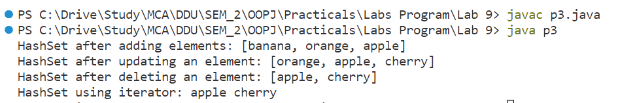

1. **Create a HashMap and perform following operations for that:**
   1. **Insert**
   2. **Update**
   3. **Delete**
   4. **Display using iterator()**

Code

import java.util.HashMap;

import java.util.Iterator;

import java.util.Map;

public class p4 {

    public static void main(String[] args) {

        // Create a new HashMap

        HashMap<String, Integer> hashMap = new HashMap<String, Integer>();

        // Insert elements into the HashMap

        hashMap.put("apple", 1);

        hashMap.put("banana", 2);

        hashMap.put("orange", 3);

        System.out.println("HashMap after adding elements: " + hashMap);

        // Update an element in the HashMap

        hashMap.put("banana", 4);

        System.out.println("HashMap after updating an element: " + hashMap);

        // Delete an element from the HashMap

        hashMap.remove("orange");

        System.out.println("HashMap after deleting an element: " + hashMap);

        // Display the HashMap using an iterator

        Iterator<Map.Entry<String, Integer>> iterator = hashMap.entrySet().iterator();

        System.out.print("HashMap using iterator: ");

        while (iterator.hasNext()) {

            Map.Entry<String, Integer> entry = iterator.next();

            System.out.print(entry.getKey() + "=" + entry.getValue() + " ");

        }

    }

}

Output

